Assignment 20 (February 27 – March 11)

1. For each of the following difference equation find the complementary function, the particular integral and the definite solution:
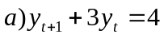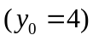
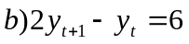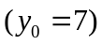
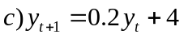

2. Find the solutions of the following, and determine whether the time paths are oscillatory and convergent:
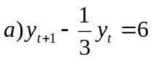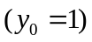
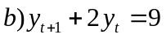
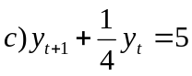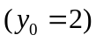
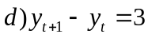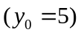

3. Solve graphically the following linear program:

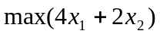
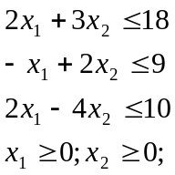
- Find the minimal value of the objective function in the linear program stated below, where is a real value parameter using the dual program
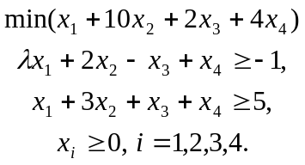

- Consider the utility maximization problem in the economy of n-goods:
 subject to the budget constraint 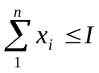, 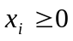, 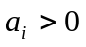.
Find the optimal bundle an check whether you found the maximum. Find the rate of change of the indirect utility function when the income slightly changes.

